Espresso Basics
Drink | Volume | Weight | Extraction Time | Comments
Espresso – Single Shot | 1 oz | 7 grams | 25 seconds
Espresso – Double Shot | 2 oz | 14 grams | 25 seconds
Espresso – Triple Shot | 3 oz | 21 grams | 25 seconds
Double Shot Cappuccino | 6.5 oz |  |  | 1/3 espresso  1/3 steamed milk  1/3 micro foam
Brewing temperature | 204 degrees F

Café cortado | ½ espresso, ½ steamed milk with minimal foam
Macchiato | Double or triple expresso with a dollop of milk foam on top
Ristretto | Like espresso but ground finer for a lower extraction volume per time
Mocha | Like cappuccino with chocolate syrup added
Breve | Cappuccino with half and half substituted for milk

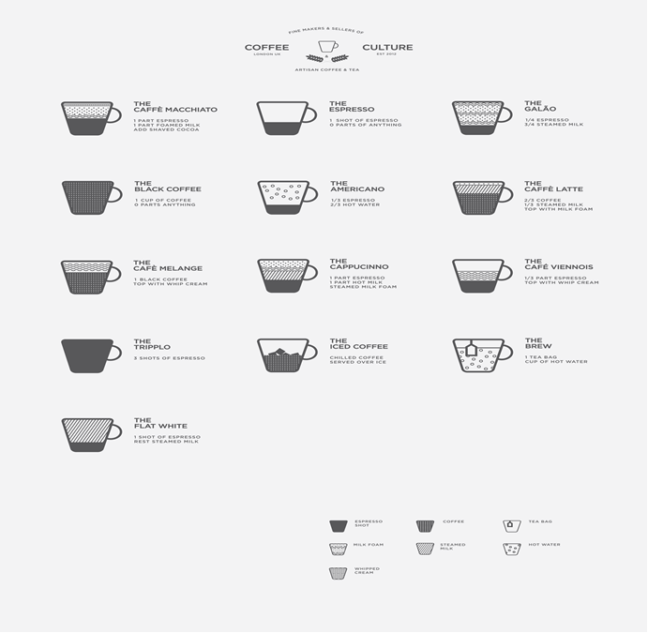http://img2.wikia.nocookie.net/__cb20120510203516/coffee/images/2/22/COFFEE_POSTER_JAMES_DAVIES.jpg

